Congratulations and a huge big welcome on your new baby!
The Photo Press would like to list (information only - no pictures please) your little bundle of joy in our Baby Buzz. We are a free weekly newspaper that reaches over 12,000 households. We’re the perfect way to spread your good news! Just fill out the attached form, drop it off, mail it or email it to us. Please include a daytime phone number in case we have any questions. We are also a full service print shop and can print custom-made baby announcements for your newest arrival!
Thank you and congratulations again!
112 E. First Street | PO Box 973 | Fairmont, MN 56031 P> 507.238.9456 | F> 507.238.9457
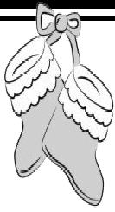
editor@fairmontphotopress.com | Monday-Friday 8 a.m. to 5 p.m.

Baby Buzz
Baby’s Name Born Weight Length Where q Son q Daughter of Address Grandparents City/State Grandparents City/State Grandparents City/State Grandparents City/State Great-Grandparents City/State Great-Grandparents City/State
(no deceased grandparents please)

Brothers Sisters Name and daytime phone number of person completing form:

